HPE-SSL Creation for Containerized application deployed on CaaS

Create a ssl private key as below:
Please generate rsa for your application:
openssl genrsa -out domain.key 2048

[root@test-cli ssl_doc_prod]# ll
-rw-r--r--. 1 root root 1675 Sep 7 18:41 domain.key

- Create a new group/use existing group from your directory works:
https://directoryworks.hpecorp.net/protected/people/view/groups/owner/

- Enter the required fields @ https://myitsupport.ext.hpe.com/myITsupport/ITSArticle?ArticleNumber=000001599

=> external or internal – based on your requirement
https://g1t6039.austin.hpecorp.net/hp/client/sslPublicStart.php

NOTE: External certificates will be charged by HPE if you intend to use it for more than 30days for your application.

If you need an external certificate for testing or development, HPE will not be charged if you revoke it within 30 days.

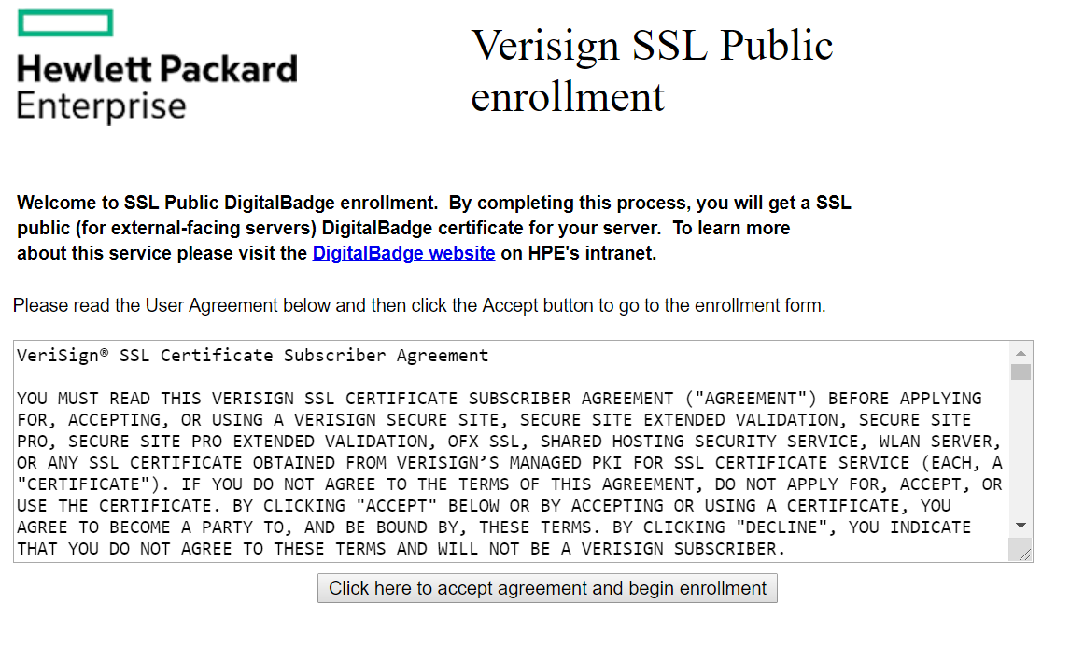
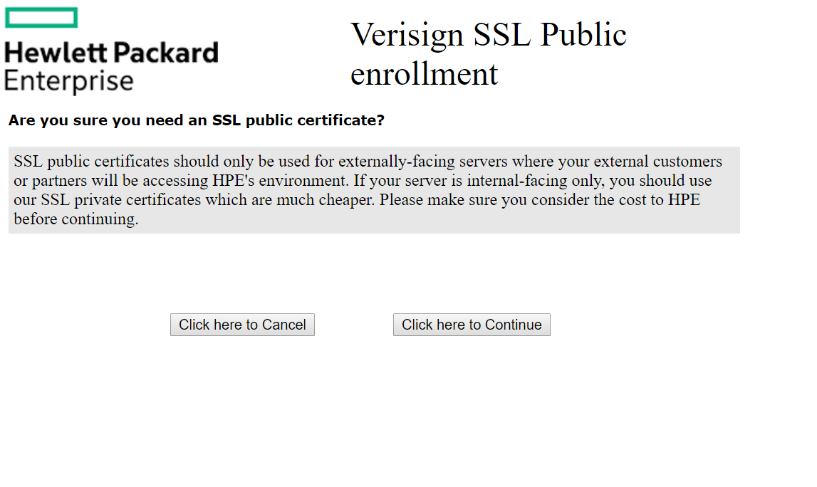
Enter the group-ID and your application EPR-ID:

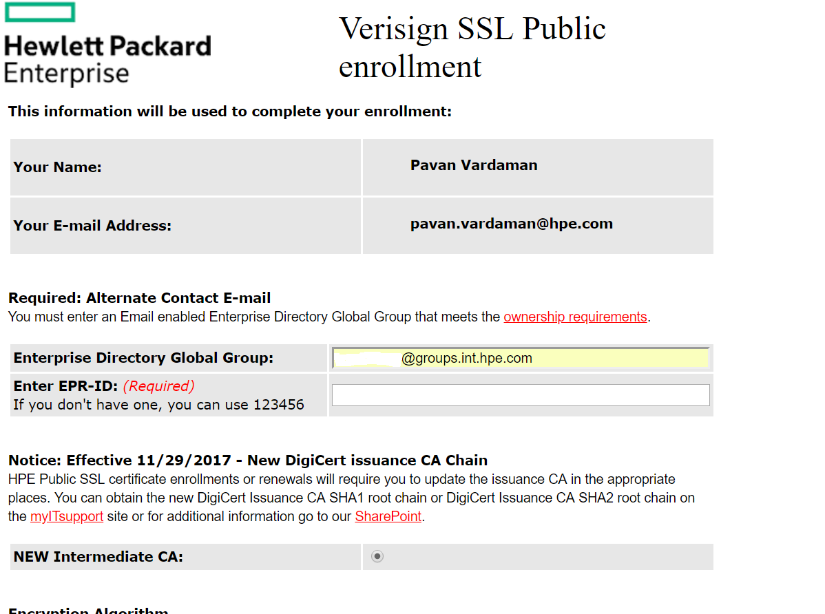
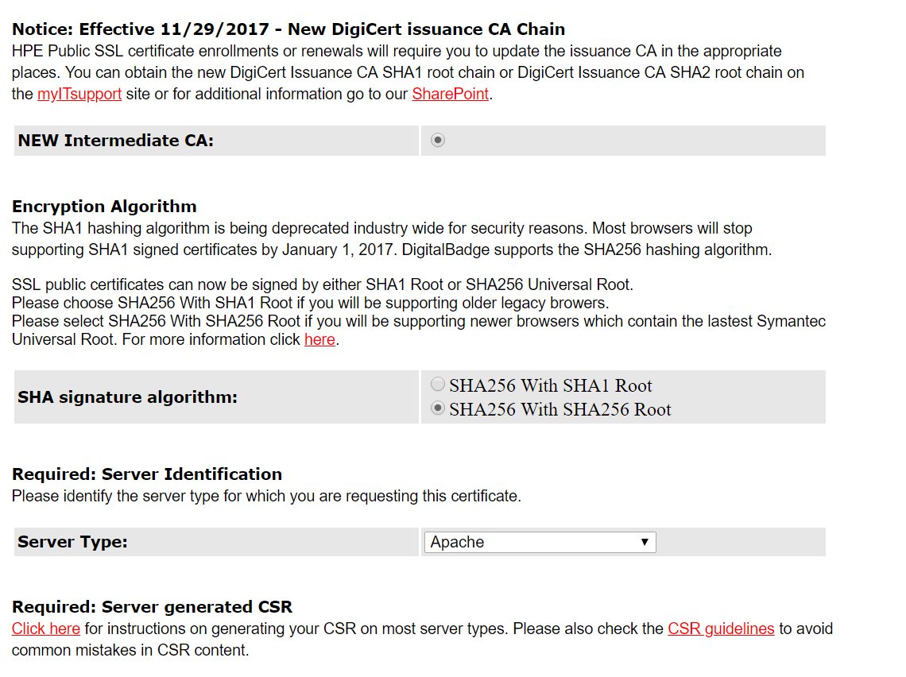

- Generate a csr based on private key(domain.key). please follow it while generating.
https://ent302.sharepoint.hpe.com/teams/credentials/_layouts/15/WopiFrame2.aspx?sourcedoc=/teams/credentials/Shared%20Documents/CSR%20Guidelines.docx&action=default

openssl req \
-newkey rsa:2048 -nodes -keyout domain.key \
-out docker-prod.csr

- Insert this csr here:
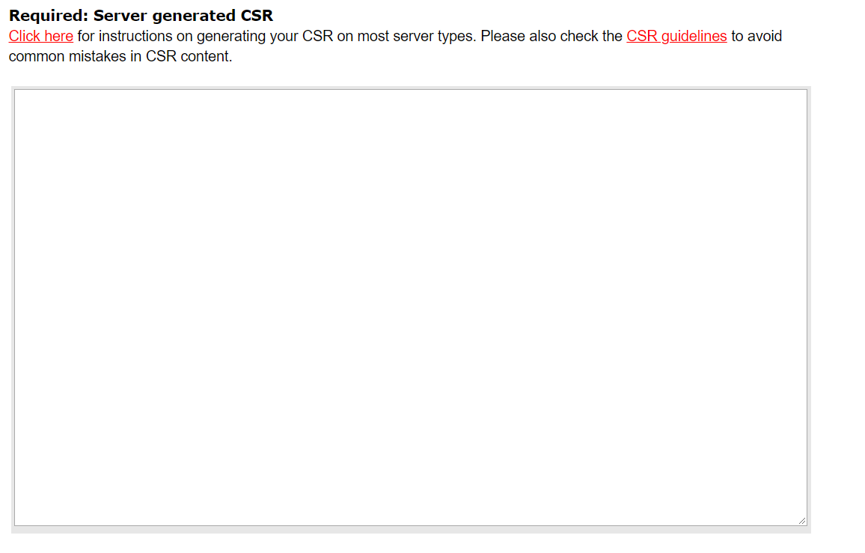
- Insert all the SAN’s (All cluster FQDN’s) here:
All the CaaS-FQDN’s list available on wiki at https://github.hpe.com/CaaSonHPE/Wiki/blob/master/CaaS-1%2C2%20IP's%20and%20it's%20Hostnames.xlsx
NOTE: Please include the specific cluster SAN’s based on your Application requirement on which environment you are hosting.
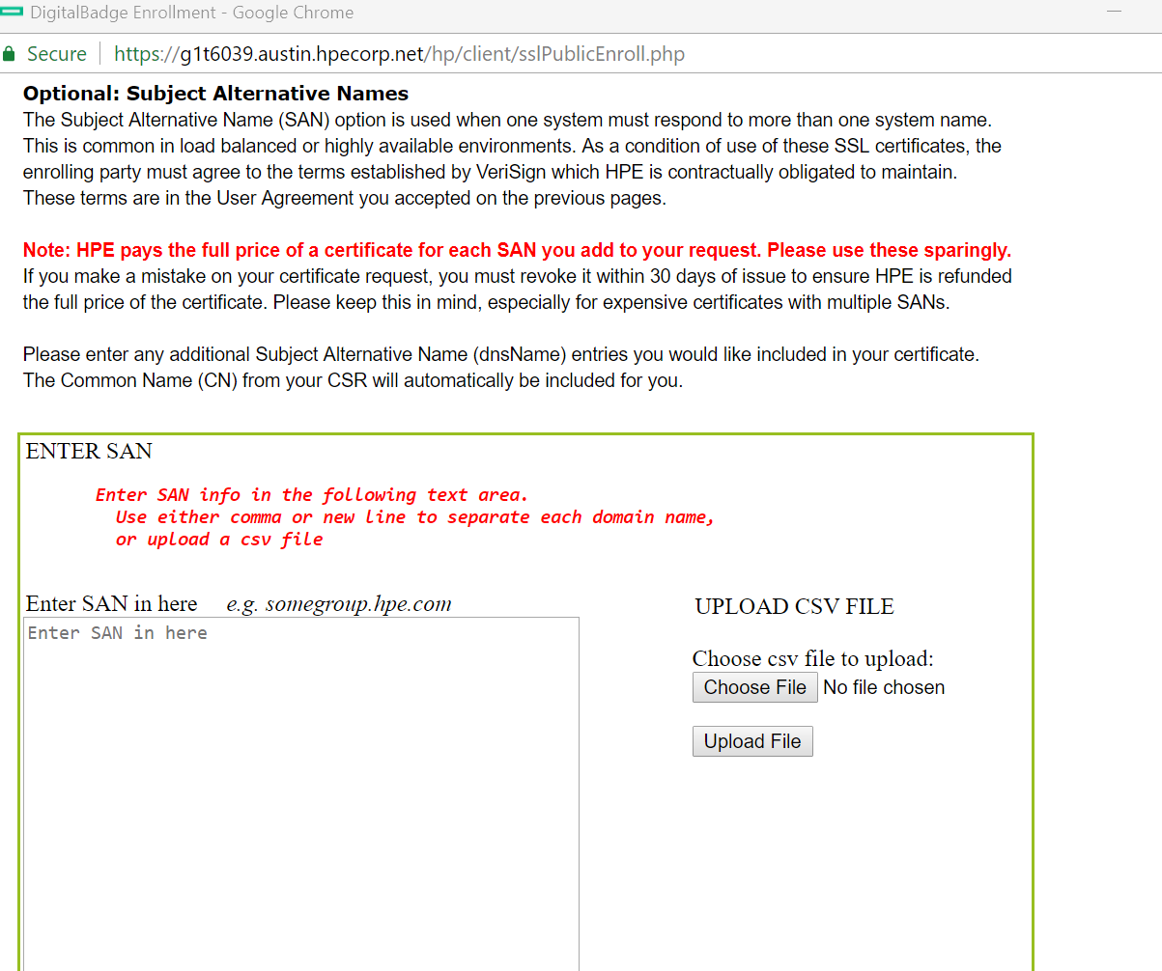

- Once it is accepted, you will get cert. the same crt will be sent you through email.

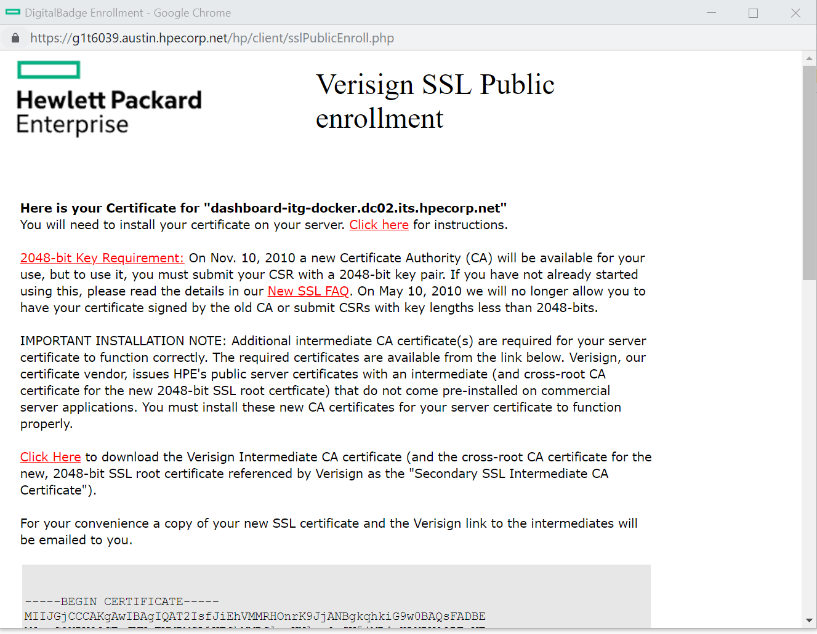

- Please use this crt for your application.

BEST PRACTICES:
Renew your SSL certificate
- Enroll for a new certificate using your existing name within 30 days of expiration to avoid downtime.
- To enroll 30+ days before expiration, revoke your certificate. It will be invalid until you obtain a new one.
- Please follow the instructions to revoke your certificate: https://myitsupport.ext.hpe.com/myITsupport/ITSArticle?ArticleNumber=000002128

